**EXERCISE NUMBER**:**5**

**DATE**:14/10/2020

**Aim:**

To write a Python function to print missing characters to make string pangram.

**Program:**

a=input()

a=set(a.strip())

a.remove(chr(32))

b="abcdefghijklmnopqrstuvwxyz"

b=set(b)

b=b.difference(a)

b=list(b)

b.sort()

print("".join(b))

**Link:**

http://103.53.53.18/mod/vpl/forms/edit.php?id=235&userid=1747#

**Output:**

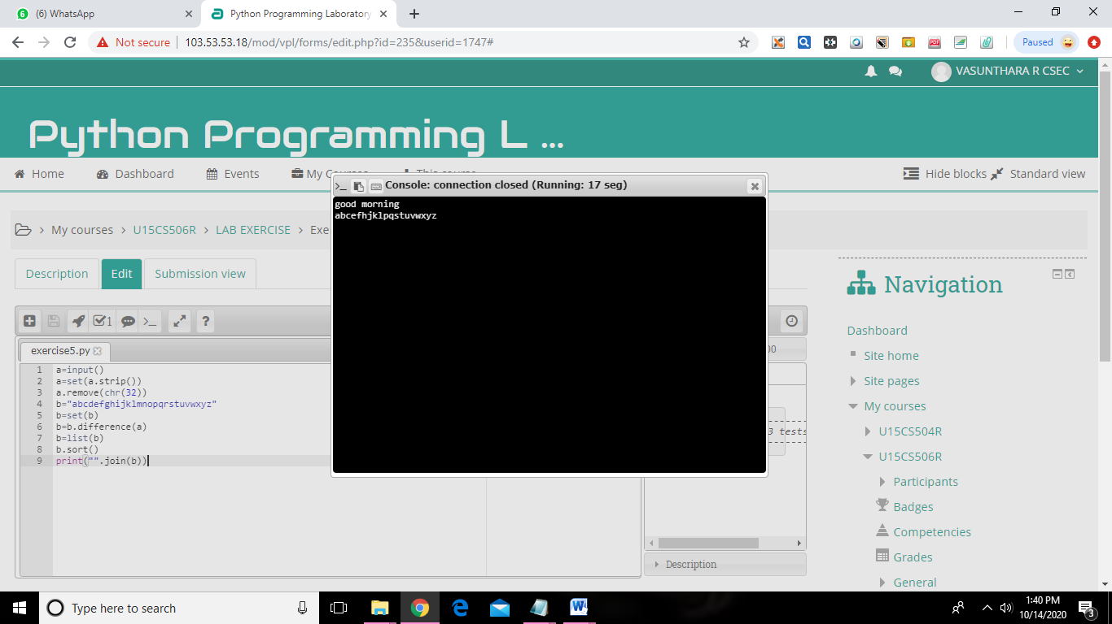

**Result:**

The program has been executed and expected output is obtained